

**Forest School Kindergarten**

**Family Handbook**

**Everything You Wanted to Know About Wyld Thyngz but Were too Frightened to Ask!**

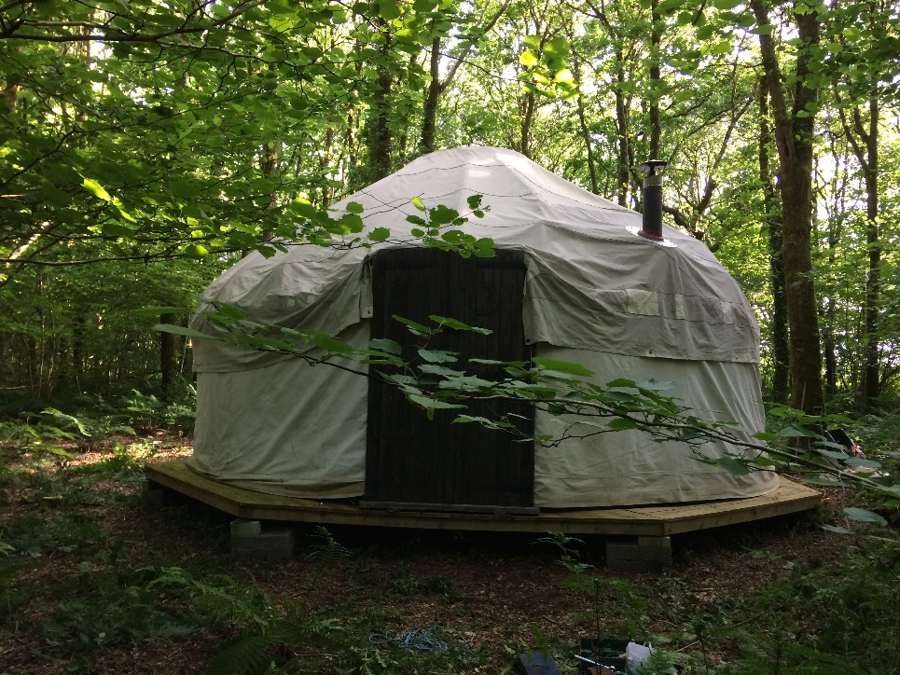

Learning in the wyld for a brighter future.

Build thyngz, make thyngz, cook thyngz, learn thyngz; be a Wyld Thyng**!**

Warning- there is a high risk of your child getting muddy and enjoying it!

**What It’s About**

Our goal is to encourage your children’s natural curiosity and fascination for exploration through play in the natural environment. This inspires opportunities for growth in self-belief and confidence as well as empowering the children to try new skills and develop their ability to manage risks.

The focus of Forest School is to experience the natural world through its ever changing cycles, stepping outside our comfort zones to develop resilience and a deeper understanding of the world around us.

This handbook is designed to give you an introduction to the kindergarten and our home school group; it contains information you need to know to get the best out of your child’s time here. More information can be found on the website and on our Facebook page Wyld Thyngz.

We rely on families being involved as much as possible, there are opportunities for volunteering during and after school hours. Please ask a member of staff for more information.

If you have any questions, comments or suggestions please do not hesitate to talk to us.

**Who** **We Are**

Wyld Thyngz is run by a small, friendly, experienced team all Disclosure and Barring Service checked.

**Kindergarten;**

The Forest School Leader is Sarah Slocombe, Leader of Wyld Thyngz Forest School Kindergarten. Sarah is a Primary Teacher and holds a BEd Hons Early Years, Forest School Leader Level 3, Safeguarding Level 3, Outdoor and Paediatric First Aid and Food Hygiene certificate.

Jayne Butland joined us in 2019 and is our SENCO. She holds a Level 3 Diploma in Children and Young Peoples Workforce, Forest School Leader Level 3, Safeguarding Level 3, First Aid in the Workplace, and Food Hygiene.

Nicola Plummer is a Level 3 Forest School Leader and is a member of our bank staff.

Simone Please is a Storyteller and regularly volunteers with us cooking and creating stories with the children.

**Why Forest School?**

Forest School values a child's ability to learn from the world around them. It gives children time to be free in a natural environment, to explore and discover their own interests. We support and encourage your child to develop a love and connection to our world and to feel valued and part of our kindergarten community.

Our kindergarten offers children regular opportunities to achieve, develop confidence and self-esteem through hands-on learning experiences in woodland.

There are huge benefits from being outdoors and the effect it has on our physical and mental well-being. Being outside is hands-on science!  What better way to learn about our world than to smell, touch and feel it all around them.

**What We Offer**

**Kindergarten (3-7 years)** runsonWednesday, Thursdays and Fridays 9.30 til 2.30 term time only, with plans to extend this to five days a week. Children are dropped off into the care of the kindergarten staff who use the woods to support the children’s learning through the Early Years Foundation Stage (EYFS) and record their progress through a secure online system called Famly. Please provide drink and packed lunch. From the age of 5 children can join Really Wyld Thyngz ( our group for home educated children, please see below).

**Parent & Child Group (0-5 years)** is held onMonday and Tuesdays mornings, 10am till 12.00 and Tuesday afternoons 1pm till 3pm all year. The group meets in a designated space throughout the year, with a temporary shelter when needed. Children and carers are offered the space to explore the woodland environment through the changing seasons and experience the gifts it shows us. We often create objects, decorations etc with the treasures we find there, we have stories and come together to share food prepared over the open fire. Please book through bookwhen.com/wyldthyngz

**Holiday Club (3-11years)** is held during the Easter and Summer holidays 9.30 till 3.30. Activities include cooking, crafts, organised games and free play, please provide a drink and packed lunch. Discounts for siblings. If you’re interested please ask a member of staff to add your email address to our list to get more updates.

**Really Wyld Thyngz (5-11 years)** Meets on Wednesdays, Thursdays and Fridays in term time, 10am till 3pm. If you are interested please ask a member of staff to add your email address to our list to get more updates. Please provide drink and packed lunch.

We offer child led exploring alongside adult led activities and games, which develops the children’s skills to care for themselves and others around them. Children are given the freedom to explore and learn at their own speed, and in their own learning style. By letting them lead their own exploration, they are developing a sense of self-worth, self-confidence and independence and flourish in their own magical world of exploration.

Being outdoors comes with a unique set of risks (from ticks to falling out of trees). Our forest school site has been assessed as being ‘as safe as is reasonable’. As part of their learning we encourage the children to assess risks; learning to manage risks and adventure has important cognitive benefits such as team-work, motivation, concentration and perseverance. We all need to take risks to discover the consequences, ‘there can be no progress without risk’ Roger Putnam.

**Where to Find Us**

Wyld Thyngz has its own private wood covering 14 acres of mixed woodland near St Mellion in Cornwall. It has a yurt, compost loo and kitchen, and there are no public footpaths or rights of way across it.

From Callington take the A388 towards Saltash. After a mile you will see a turning to the right signed Amy Tree. Follow this road to the end and then take the road signed Pillaton. After about a mile this road narrows, soon after you will see a sign for Keason Farm on the right, the track to the woods is opposite this on the left of the road. Follow the track to the car park.

From Saltash, take the A388 towards Callington until you reach the roundabout with a left turning to Hatt. Follow the road through the village and continue for 3.5 miles until you see a sign for Keason Farm on the left. The track for the woods is opposite on the right of the road. Follow the track into the car park.

**What 3 Words; Tubes: Beaten: Diary**

**What We Wear**

**‘There’s no such thing as bad weather, only unsuitable clothing.’**

Alfred Wainwright

We strongly recommend that your child wears long sleeve tops and long trousers all year round, this is particularly important in the summer to protect from tick bites, sun burn, stinging nettles and thorns. They will also need;

* Child sized or small ruck sack, suitable lunch box and drinks bottle.
* Complete change of clothing that is relative to the weather and season. It would be helpful if these were labelled.
* Waterproof coat and trousers.
* Sun hat and labelled sun cream or winter hat and gloves.
* Slippers will be needed in the winter months to keep feet warm in the yurt.
* Good sturdy shoes or welly boots all year round.

Please see the attached sheet on dealing with ticks and Lymes Disease.

**Who Can Be A Wyld Thyng**

Children need to be 3 years old to before they can start in the kindergarten. We hold a waiting list arranged by dates in birth order, but we also consider;

* Circumstances affecting the family
* Referrals from outside agencies
* Siblings previously or already attending Wyld Thyngz

Please note, from the term after their 5th birthday up until their 8th birthday we have a limited number of spaces. These are designated on a first come first served basis.

It is recommended that for a child to benefit the most out of the sessions, they attend for a minimum of 2 days per week.

You will be notified as soon as a place becomes available for your child and a visit to the kindergarten will be arranged.

Please note once your child is attending the kindergarten we require half a term’s notice in writing if your child no longer requires their place.

**What We Charge**

Non-funded hours are charged at £5.30 per hour.

We accept the funding for eligible 3 and 4 year olds.

To ensure that the kindergarten is sustainable we also ask for a voluntary payment based on the number of hours your child attends. These funds will be used to invest back into the kindergarten to provide healthy snacks, drinks, firewood and to enable us to work with lower ratios of children to adults and to employ quality, qualified staff.

An invoice will be produced at the beginning of half term, clearly defining what fees are due (if any) and a separate entry for the voluntary payment. Please support us if you can.

We are reliant on prompt payment of fees and arrears can cause problems for the kindergarten. If you anticipate problems with payment, please speak to a member of staff as soon as possible.

**Early Years Pupil Premium (EYPP) -**Parents claiming their 3/4year old free entitlement may also be able to claim an additional allowance to support their individual child’s needs at the setting. Please ask a member of staff for details of the criteria and how to apply.

**Childcare Voucher Schemes**

We are also registered with several childcare voucher companies including the Governments Tax – Free Childcare scheme. Please ask for details.

**What Else?**

**Allergies and intolerances**

Please notify the staff if your child has any allergies or intolerances.

**Food**

We provide a healthy snack and drink mid-morning, often the children will have helped cook this on the fire. Children bring their own packed lunch and water to drink.

**Can’t Make It?**

If your child is unable to come to kindergarten for any reason, please notify staff by 9am by text or phone call. Similarly, if your child is going to be late, please let the kindergarten know as soon as possible. If we don’t hear from you by 11am we will give you a call to make sure you are still coming.

**Dropping Off and Collecting**

We depend upon you to help us manage the traffic down our narrow access track so please drive no faster than 5 miles per hour to avoid accidents and car damage. Please drop off between 09.20 and 09.30 and collect between 2.30 and 2.40 for the kindergarten, and 9.50 and 10.00 and 2.50 and 3.00 for Really Wyld Thyngz.

At the end of the day, once you have collected your child, we have no problem with children playing in the car park but it is the parents responsibility.

We aim to lock the main gate by 3.15 each day. Be prepared to wait until the last car has arrived for your group before getting ready to leave. This is the only way we can make your journeys safer and more pleasant; otherwise you will meet oncoming traffic in the access track and be forced to reverse!

**Car Sharing**

For the reasons above, and because it is the right thing to do, please try to car share with other parents/carers as much as possible. There is free car parking in Callington and Saltash where you can rendezvous; we will try to help match up different families coming from similar directions.

**Illnesses**

We have separate policies covering how we manage your child’s illnesses, allergies and medication; please ask a member of staff for a copy.

**Child Protection and Safeguarding**

Please make sure you read our policies. These are available online or we can give you a paper copy. We can also make them available in another language of your choice, please speak to a member of staff. This setting is registered with Ofsted and is required to meet the requirements of the Early Years Foundation Stage 2012; childcare register. If you have any safeguarding concerns, please first speak to Sarah Slocombe. Further to this please telephone the Local Authority Designated Officer and Ofsted.

**Special Educational Needs and Disabilities**

We operate within the SEND Code of Practice; <https://www.gov.uk/government/publications/send-code-of-practice-0-to-25> this gives us clear guidelines on identifying and supporting children with SEN and disabilities and working closely with their families and outside agencies.

**COVID-19**

We are following current government guidelines.

**Some Legal Stuff**

Wyld Thynz is a limited liability company owned by Sarah Slocombe. Wyld Thyngz Limited is the owner of the woods. Its company number is 10513736 and its registered office is at Trelyn, Frogwell Road, Callington, Cornwall, PL17 7HN.

We welcome your comments and suggestions any time.

**Important Contact Information**

**Postal Address** Trelyn,

Frogwell Road,

Callington,

Cornwall PL17 7HN

**Phone** 07581845455

**Email** [wyldthyngz.cornwall@gmail.com](mailto:wyldthyngz.cornwall@gmail.com)

**Facebook** ‘Wyld Thyngz’

**Website** www.wyldthyngz.co.uk

**Child Protection Officer** Sarah Slocombe 07581845455

**Special Needs Co-ordinator** Jayne Butland 07878889831